Semester Two Examination 2015

Question/Answer booklet

MATHEMATICS
METHODS UNITS 1 & 2

Section Two:
Calculator-assumed

Student Name: _____________________________________

Teacher’s Name: _____________________________________

Time allowed for this section
Reading time before commencing work: ten minutes
Working time for paper: one hundred minutes

Material required/recommended for this section

To be provided by the supervisor
This Question/Answer booklet
Formula Sheet (retained from Section One)

To be provided by the candidate
Standard items: pens (blue/black preferred), pencils (including coloured), sharpener, correction tape/fluid, erasers, ruler, highlighters

Special Items: drawing instruments, templates, notes on two unfolded sheets of A4 paper, and up to three calculators approved for use in the WACE examinations.

Important note to candidates
No other items may be taken into the examination room. It is your responsibility to ensure that you do not have any unauthorised notes or other items of a non-personal nature in the examination room. If you have any unauthorised material with you, hand it to the supervisor before reading any further.
Structure of this paper

 | Number of questions available | Number of questions to be attempted | Working time (minutes) | Marks available | Percentage of exam
Section One  Calculator—free | 8 | 8 | 50 | 50 | 35
Section Two  Calculator—assumed | 13 | 13 | 100 | 100 | 65
 |  |  |  |  | 100

Instructions to candidates

- The rules for the conduct of Western Australian external examinations are detailed in the
Year 12 Information Handbook 2015. Sitting this examination implies that you agree to abide by these rules.

- Answer the questions according to the following instructions.

Show all your working clearly. Your working should be in sufficient detail to allow your
answers to be checked readily and for marks to be awarded for reasoning. Incorrect answers given without supporting reasoning cannot be allocated any marks. For any question or part question worth more than two marks, valid working or justification is required to receive full marks. If you repeat an answer to any question, ensure that you cancel the answer you do not wish to have marked.

It is recommended that you do not use pencil, except in diagrams.

- You must be careful to confine your responses to the specific questions asked and to follow any instructions that are specific to a particular question.

- Spare pages are included at the end of this booklet. They can be used for planning your responses and/or as additional space if required to continue an answer.
- Planning: If you use the spare pages for planning, indicate this clearly at the top of the page.
- Continuing an answer: If you need to use the space to continue an answer, indicate in the original answer space where the answer is continued, i.e. give the page number. Fill in the number of the question that you are continuing to answer at the top of the page.

- The Formula Sheet is not handed in with your Question/Answer Booklet.

Section Two: Calculator–assumed 65% (100 marks)

This section has thirteen (13) questions. Attempt all questions. Write your answers in the spaces
provided.

Spare pages are included at the end of this booklet. They can be used for planning your responses
and/or as additional space if required to continue an answer.

- Planning: If you use the spare pages for planning, indicate this clearly at the top of the page.
- Continuing an answer: If you need to use the space to continue an answer, indicate in the original answer space where the answer is continued, i.e. give the page number. Fill in the number of the question(s) that you are continuing to answer at the top of the page.

Working time: 100 minutes

Question 9 (7 marks)

A sequence is defined by

(a) State the first three terms of the sequence. (1 mark)

(b) Give the general term, T_{n}, of the sequence in terms of n. (2 marks)

(c) Determine S_{n}, the sum to n terms, of the sequence in terms of n. (2 marks)

(d) State the least value of n, such that 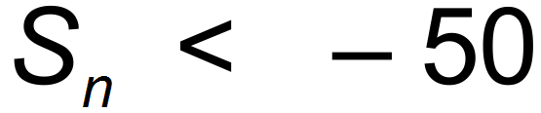. (2 marks)

Question 10 (6 marks)

A particle is undergoing rectilinear motion, such that its displacement, x m, at any time t seconds,
is shown on the sketch below.
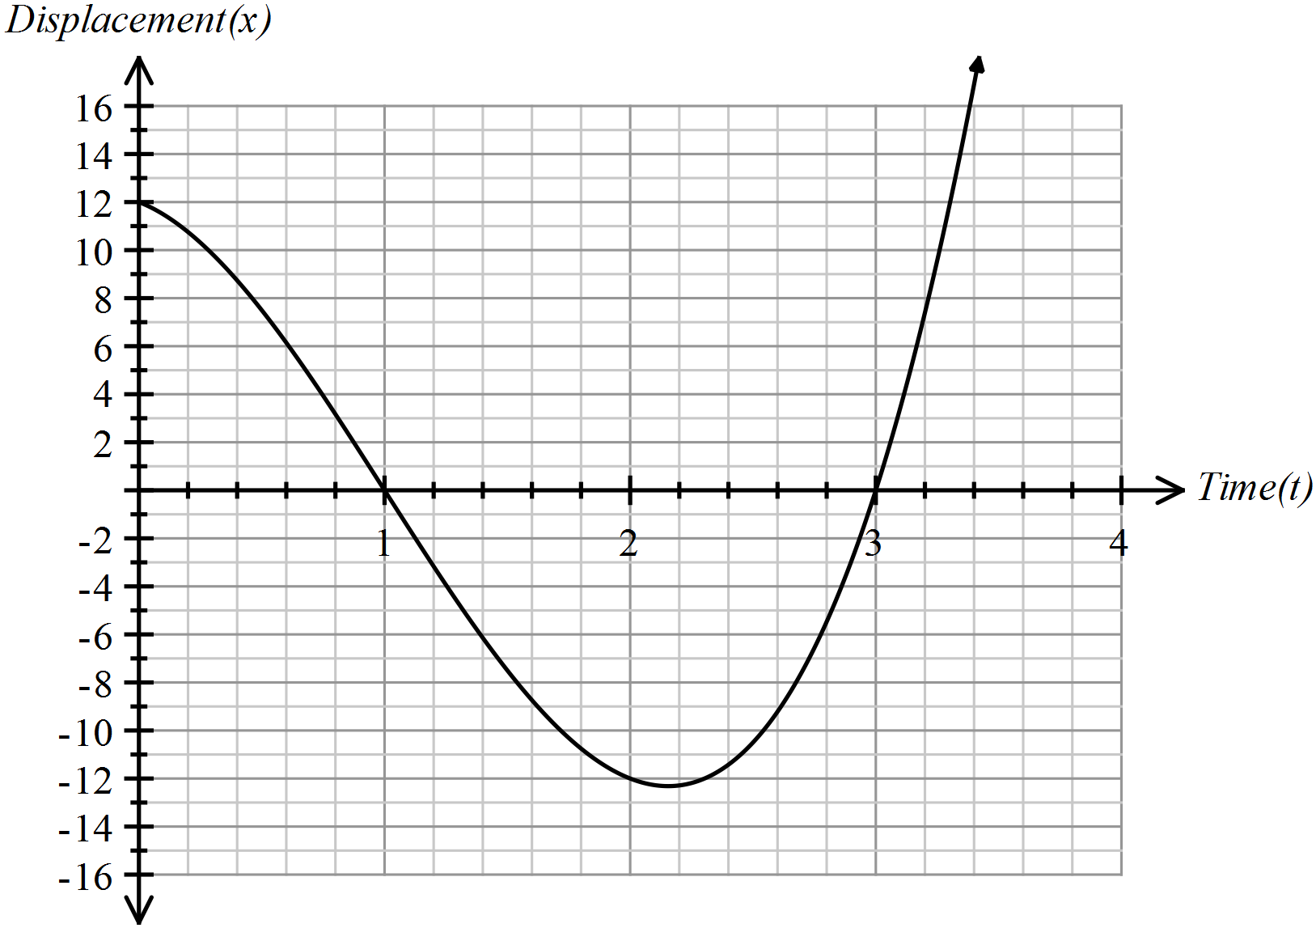

(a) Determine:

(i) the initial displacement of the particle. (1 mark)

(ii) the first time, correct to one decimal place, that the particle is stationary. (1 mark)

(iii) the time(s) that the particle passes through the origin. (1 mark)

(iv) the approximate distance the particle has travelled in the first three seconds. (1 mark)

(b) Estimate the velocity of the particle at t = 1. Explain your reasoning clearly. (2 marks)

Question 11 (6 marks)

The graph of 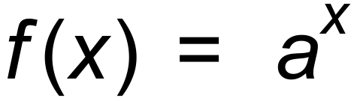 is drawn below.
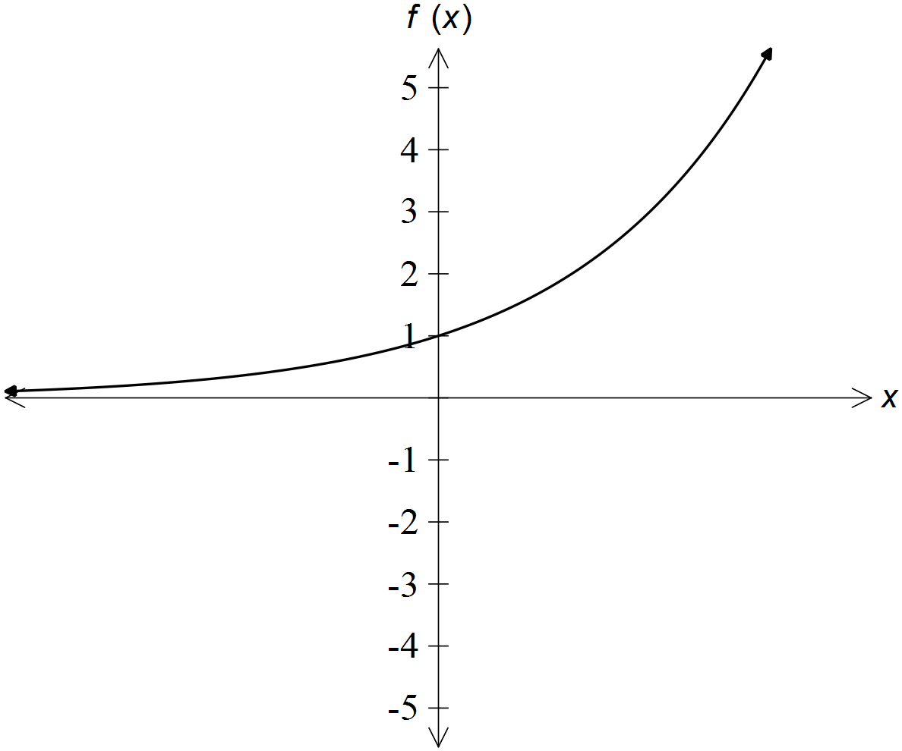

(a) Sketch on the axes the following functions. Clearly label each one.

(i) 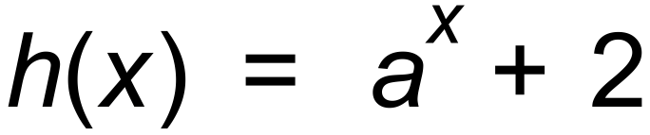 (2 marks)

(ii) 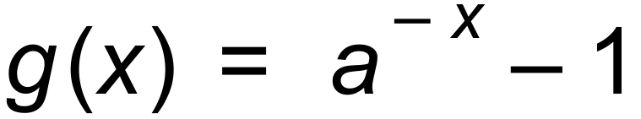 (2 marks)

(b) Which of the following situations could the above graph f(x) , for x > 0,
possibly represent? (2 marks)

Circle the answer(s).

(i) Radioactive decay.

(ii) Increasing population of a rare penguin.

(iii) Bank account attracting compound interest.

(iv) Decreasing population of white rhinos.

Question 12 (7 marks)

Consider the function 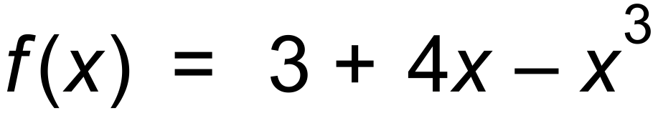.

(a) For x = 2.1 to x = 2.2 determine:

(i) 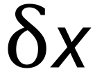 (1 mark)

(ii) 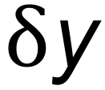 (2 marks)

(b) Determine the value of f ′(2). (2 marks)

(c) Determine the point(s) where the tangent to the function f(x) is parallel to the x axis. (2 marks)

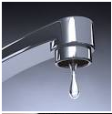
Question 13 (13 marks)

A tap has a leak. An 8L bucket is placed underneath it when the owners
of the house go on holiday.
The first day, the volume of water that leaked was 300 mL. The second
day, the water volume of water that leaked was 285 mL and the third
day, the volume was 270.75 mL. The sequence continued until the owners
returned.

(a) What type of sequence is being developed by the volume of water leaking? (1 mark)

(b) State:

(i) the recursive definition of the sequence. (2 marks)

(ii) the general term of the sequence. (2 marks)

(iii) the volume of water leaking on the tenth day, correct to
four significant figures. (2 marks)

(c) On which day will the volume of water leaking be less than 50 mL for the
first time? (2 marks)

(d) What is the total amount of water that has leaked by the end of the twelfth day? (2 marks)

(e) Show mathematically why the bucket will never overflow. (2 marks)

Question 14 (8 marks)

A cubic function is defined to be , where a and b are constants.

Determine:

(a) (i) roots of f (x). (1 mark)

(ii) the y−intercept of f (x). (1 mark)

(b) State possible value(s) of a for each of the following.

(i) 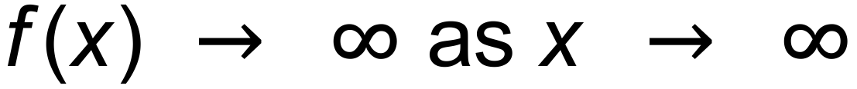. (1 mark)

(ii) . (1 mark)

(c) State the value of b for each of the following, if the graph of f (x) is shown below.

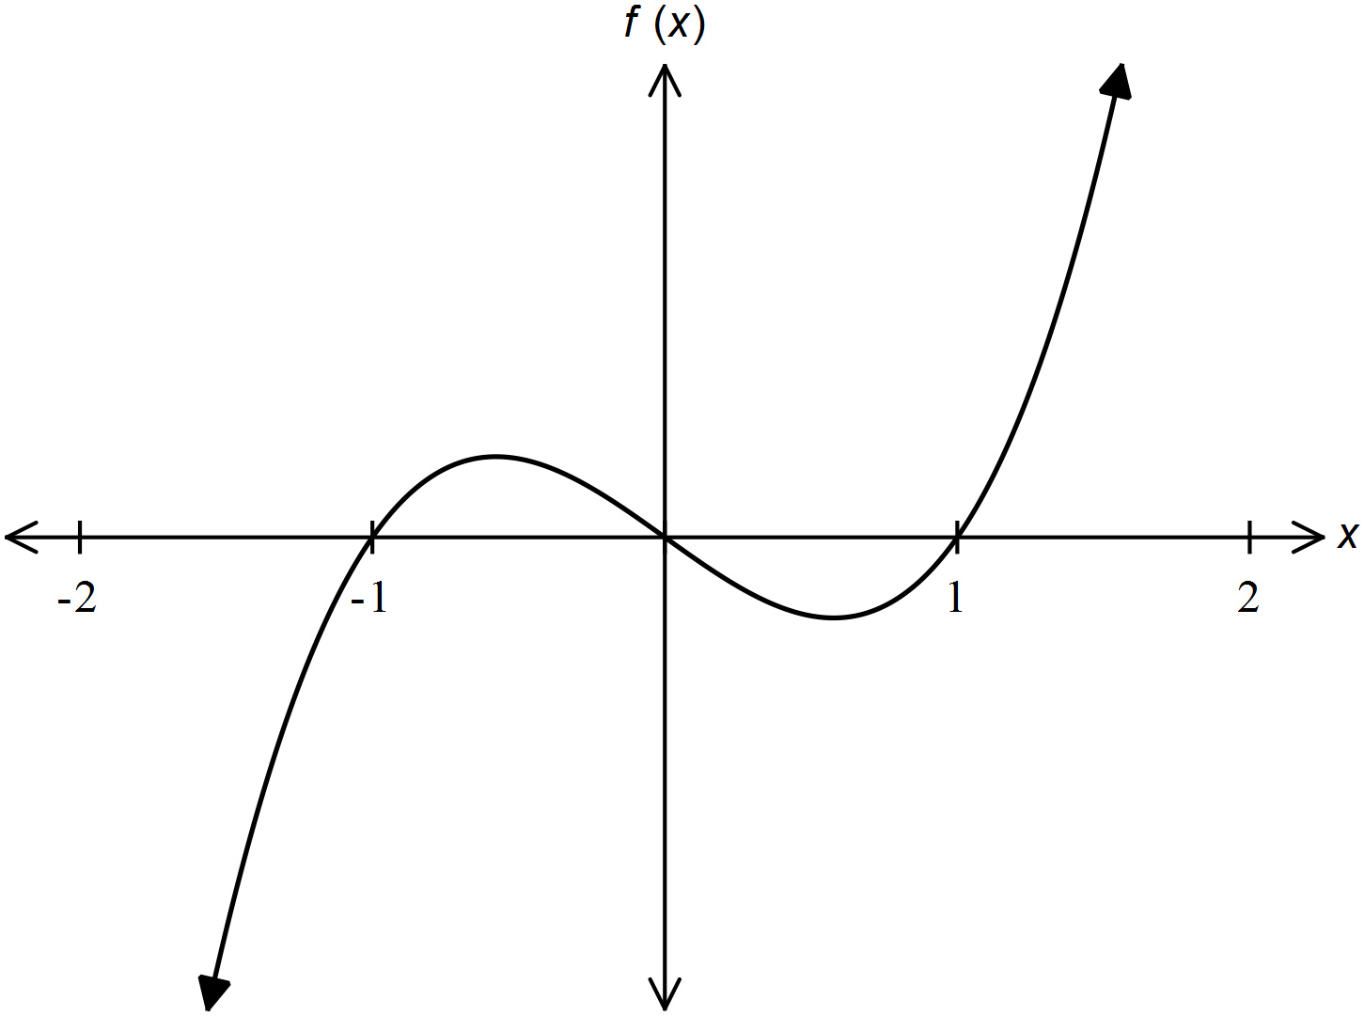 (i) (1 mark)

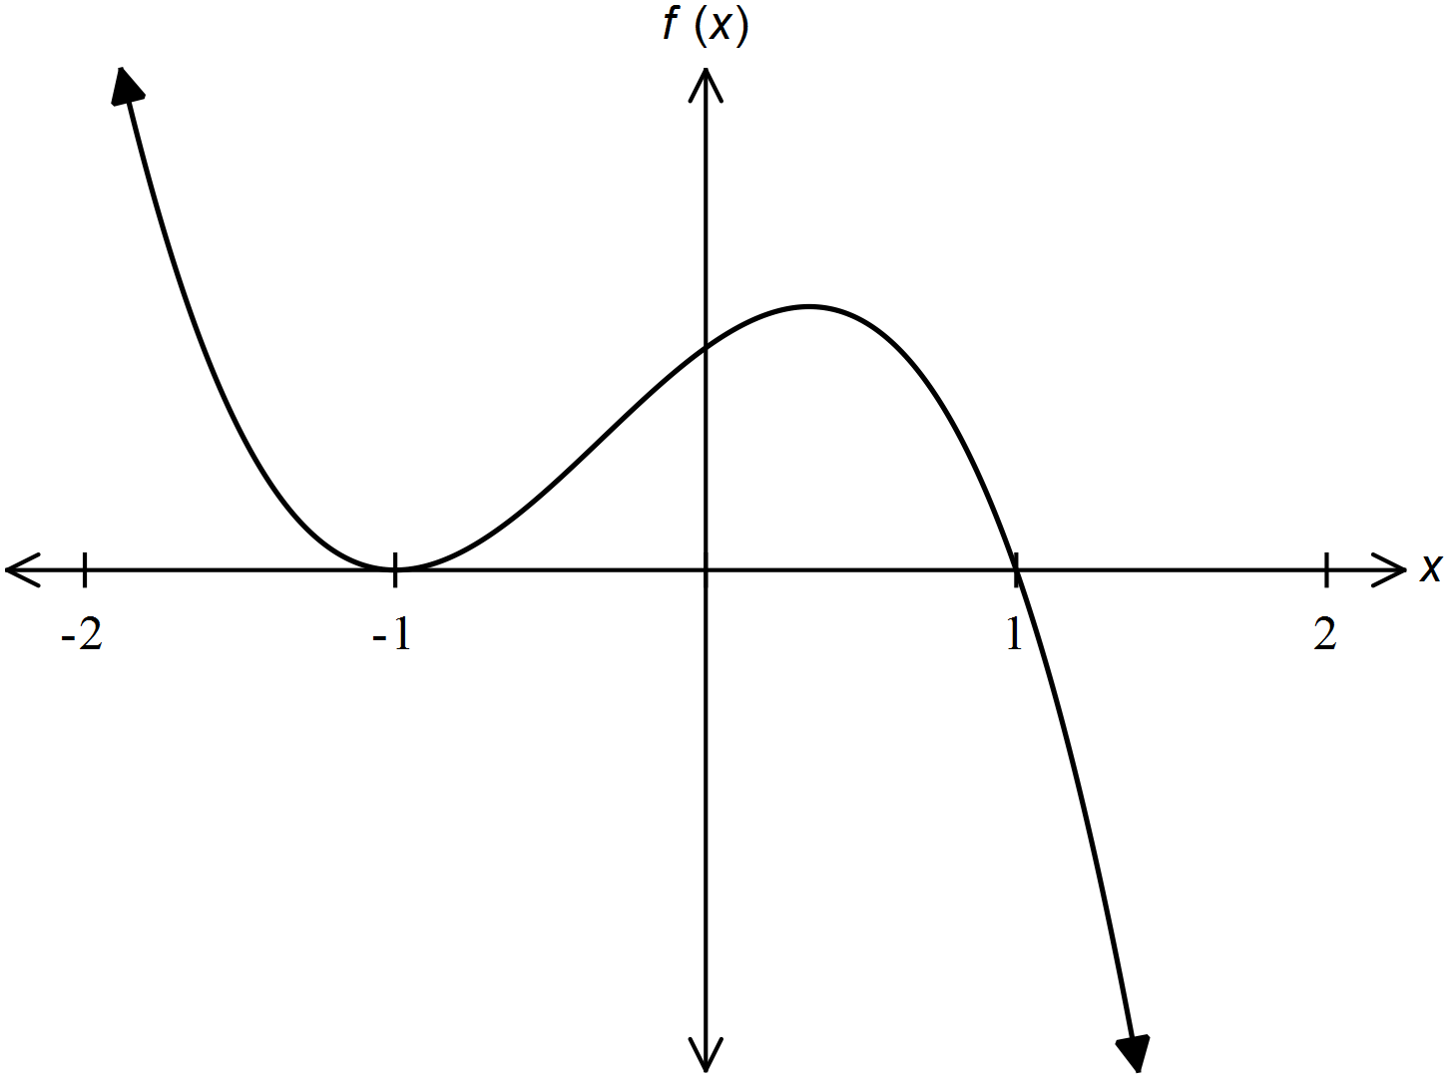

(ii) (1 mark)

(d) Determine f ′(x). (2 marks)

Question 15 (8 marks)

The graph of h (x) is shown below.
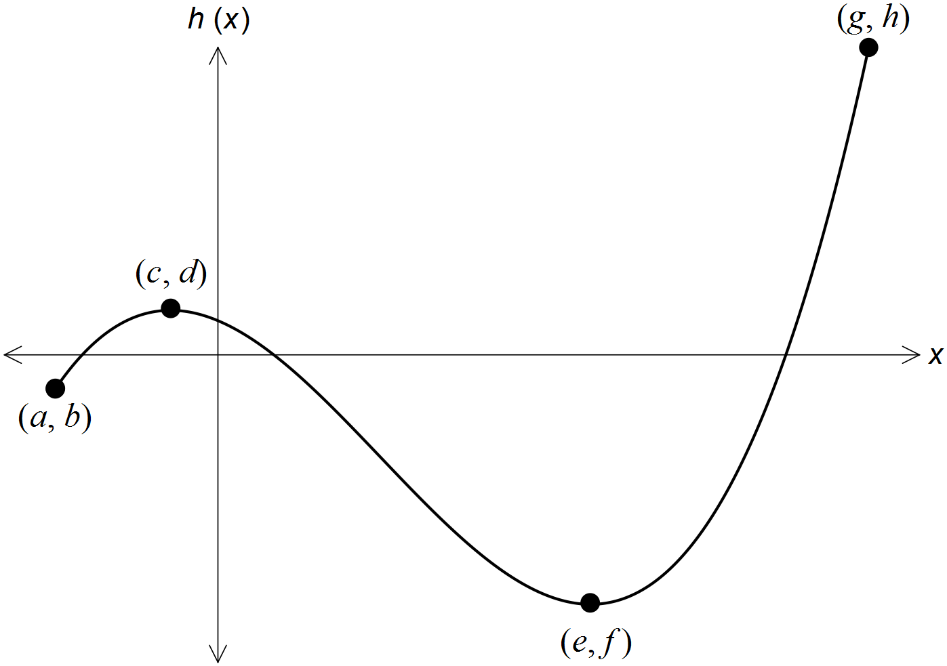

(a) Determine the coordinates of:

(i) the local minimum. (1 mark)

(ii) the global maximum. (1 mark)

(iii) the global minimum. (1 mark)

(iv) any stationary point(s). (2 marks)

(b) Determine the range of value(s) of x such that: (1 mark)

(i) f ′(x) < 0

(ii) f ′(x) > 0 (2 marks)

Question 16 (6 marks)

The perimeter of a rectangular rug is 8 m.
Let the length of the rug be x m.

(a) Show that the area of the rug is 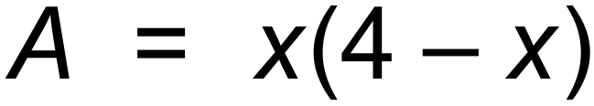 m². (2 marks)

(b) Use Calculus to determine the maximum area of the rug. (3 marks)

(c) Use the sign test to show the area is a maximum. (1 mark)

Question 17 (9 marks)

The regional mixed netball team of 12, is to be chosen from 8 men and 12 women who are trialling.

(a) How many different teams are possible if:

(i) there are no restrictions? (1 mark)

(ii) there must be 6 men and 6 women? (2 marks)

(iii) there must be more women than men, but at least 4 men? (2 marks)

David, a male, and Lisa, a female, are two of the players trialling.

(b) How many teams are possible if:

(i) David is not selected, and there are exactly 5 males selected? (2 marks)

(ii) David and Lisa are not to be selected in the same team, and there are
exactly 8 females included? (2 marks)

Question 18 (8 marks)

A function f (x) is defined to be 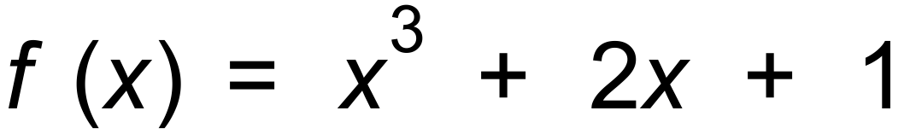.

Determine the equation of the new function if transformed by the following.
Simplify your answers.

(a) A vertical translation 2 up. (1 mark)

(b) A horizontal translation 1 right. (1 mark)

(c) A reflection in the y−axis. (1 mark)

(d) A vertical dilation of factor 3, followed by a horizontal dilation of factor  . (2 marks)

(e) A horizontal dilation factor 2, followed by a horizontal translation of 2 left,
followed by a reflection in the x−axis. (3 marks)

Question 19 (7 marks)

A yacht is racing in a local event.
The course is given below.
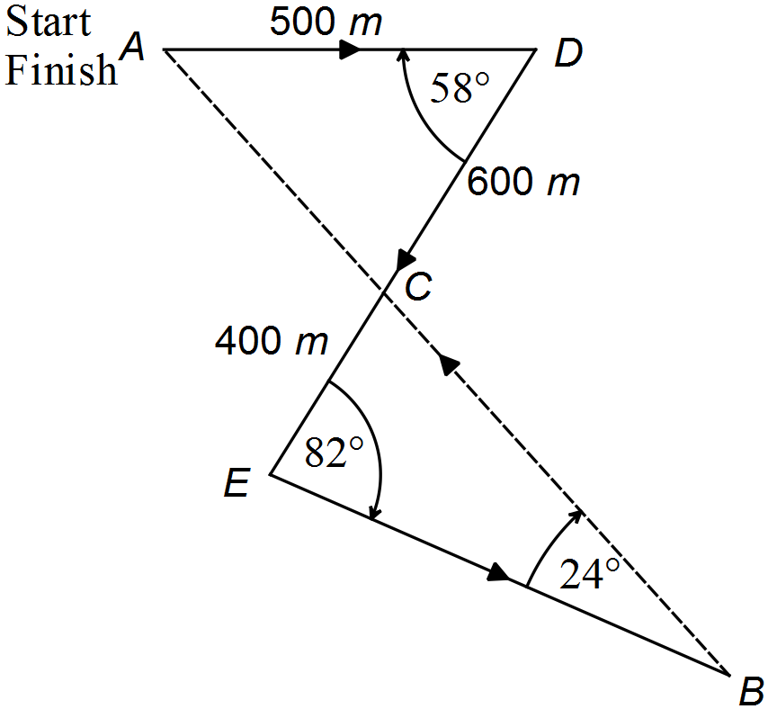

(a) Show how to use the cosine rule to determine AC, correct to two decimal places. (2 marks)

(b) Show how to use the sine rule to determine CB, correct to two decimal places. (2 marks)

(c) Determine the area enclosed by the whole course, correct to four significant digits. (3 marks)
Question 20 (8 marks)

A class of 30 students was asked which of two sports they participate in.
The results are given in Venn Diagram format, where M is male, T is Tennis and B is Badminton.

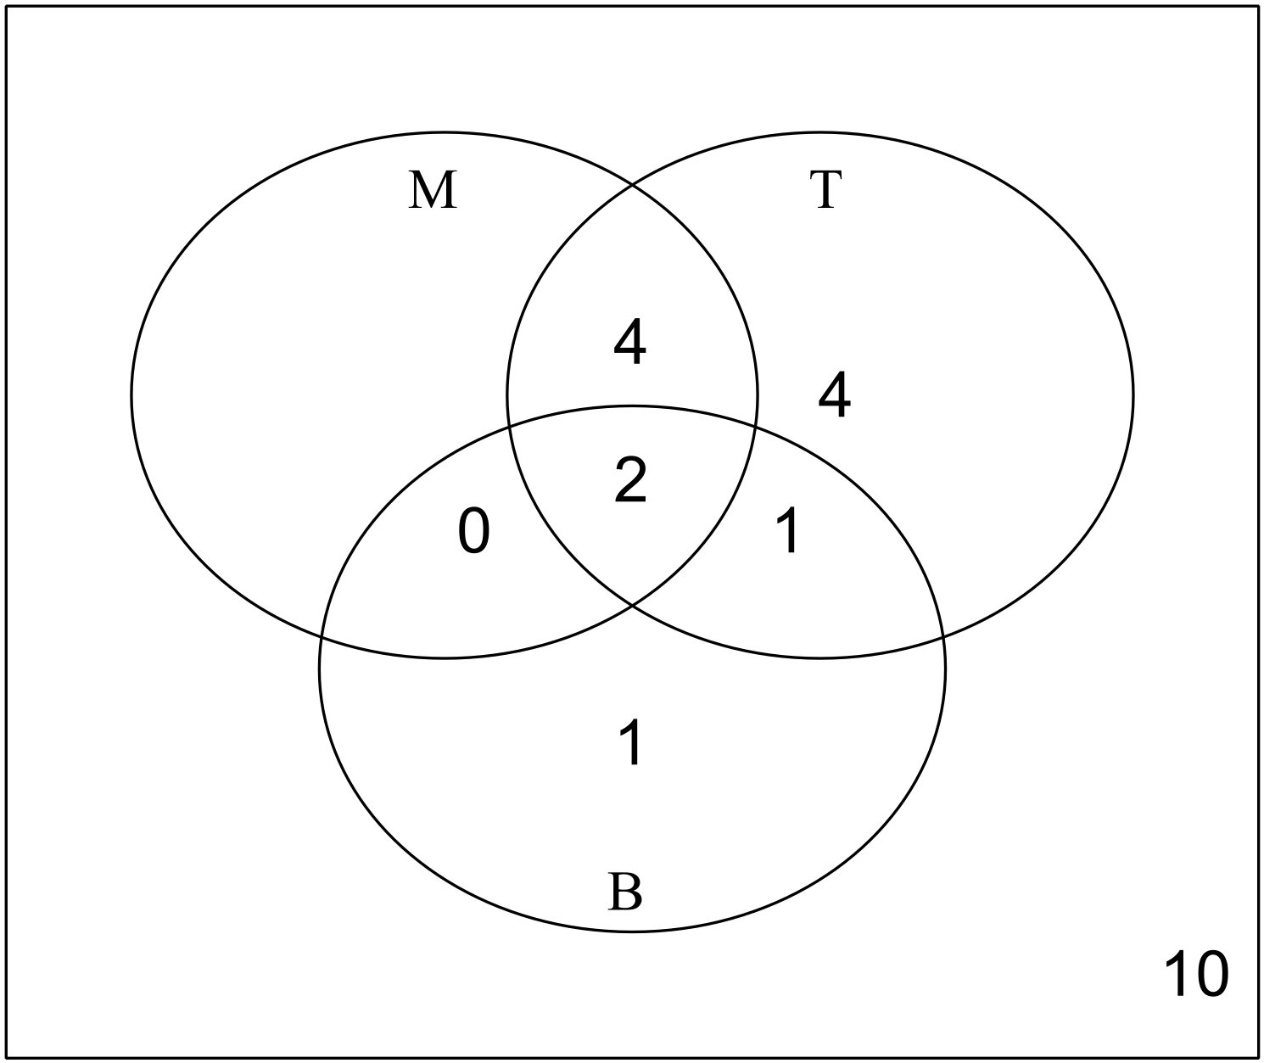

(a) How many males do not participate in either sport? (1 mark)

(b) Determine the probability that a student chosen at random, from this class:

(i) participates in tennis. (1 mark)

(ii) is a girl. (1 mark)

(iii) is a male and does not participate in badminton. (1 mark)

(iv) participates in tennis, given that person is a male. (2 marks)

(c) What does M ∩ T ∩ B mean in the context of the question? (1 mark)

(d) The events; “Male” and “Badminton” are not Mutually Exclusive. Explain. (1 mark)

Question 21 (7 marks)

The graphs of the following relations, where a, b and c are constants, are sketched below.

(i) 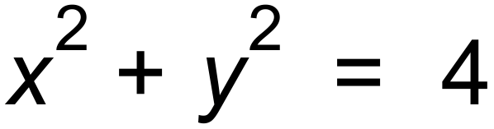 (ii) 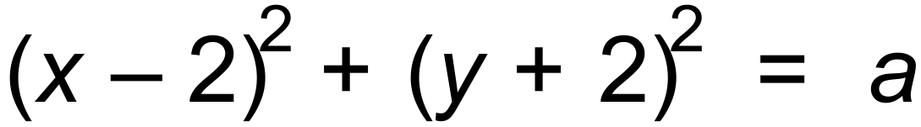

(iii) 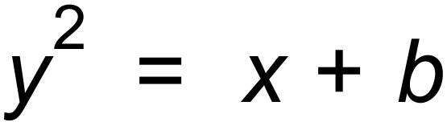 (iv) 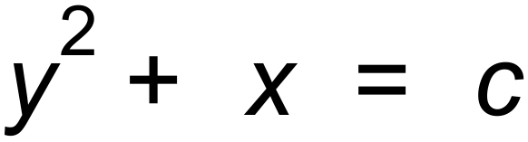
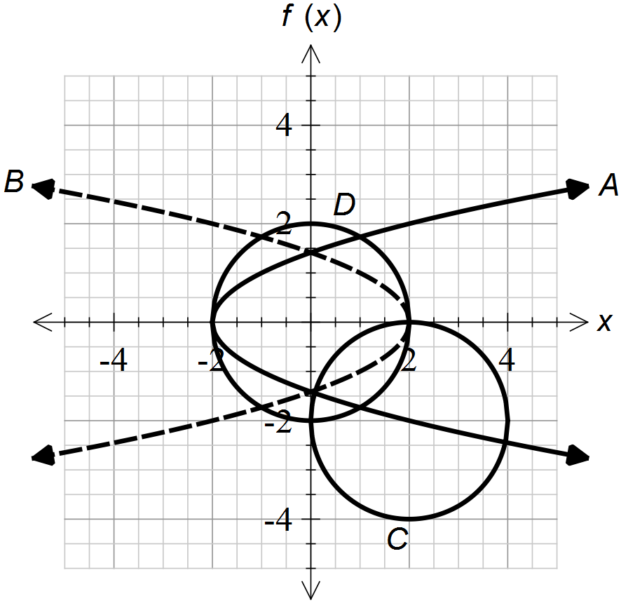

(a) Match the graphs to the relations. (4 marks)

A | B | C | D

(b) Determine the values of a, b and c. (3 marks)

End of questions
Additional working space

Question number(s): ……………………

Additional working space

Question number(s): ……………………

